17.102: The ratio of the masses is
so 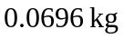of steam supplies the same heat as 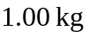 of water. Note the heat capacity of water is used to find the heat lost by the condensed steam.

